**Task 1: สร้าง User Accounts สำหรับ Team (30นาที)**

1.1 สร้าง Users และ Groups

|  |  |  |
| --- | --- | --- |
| Groups | Users | password |
| Developers | supawit | 1234 |
| Testers | chawanrak | 1234 |
| DBadmin | supawit2 | 1234 |

Screenshots การจัดการ user accounts

1.2 ตั้งค่า password policy

1.3 ใช้คำสั่งทดสอบ

**Task 2: ตั้งค่า Sudo permission (45นาที)**

2.1 สร้าง Sudo Groups

2.2 Configure sudoers

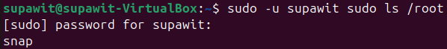2.3 ทดสอบ sudo permissions

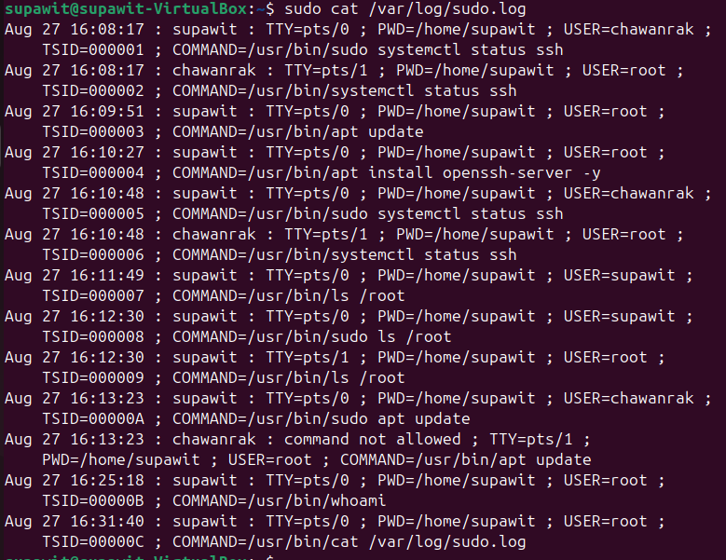

**Task 3: Configure ssh Security (45 นาที)**

3.1 Backup และแก้ไข SSH Config

3.2 สร้าง SSH keys





3.3 configure SSH Banner

3.4 Restart SSH และ ทดสอบ





**Task 4: Set up Firewall Rules (30 นาที)**

4.1 Configure UFW

4.2 Advance UFW Rules

**Task 5: Enable System Monitoring (60 นาที)**

5.1 Install Monitoring Tools

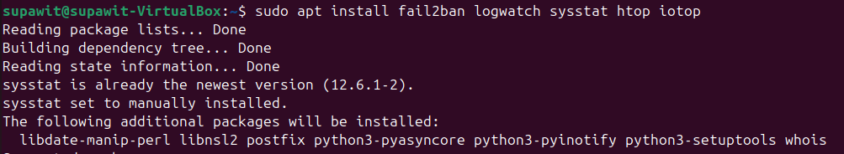



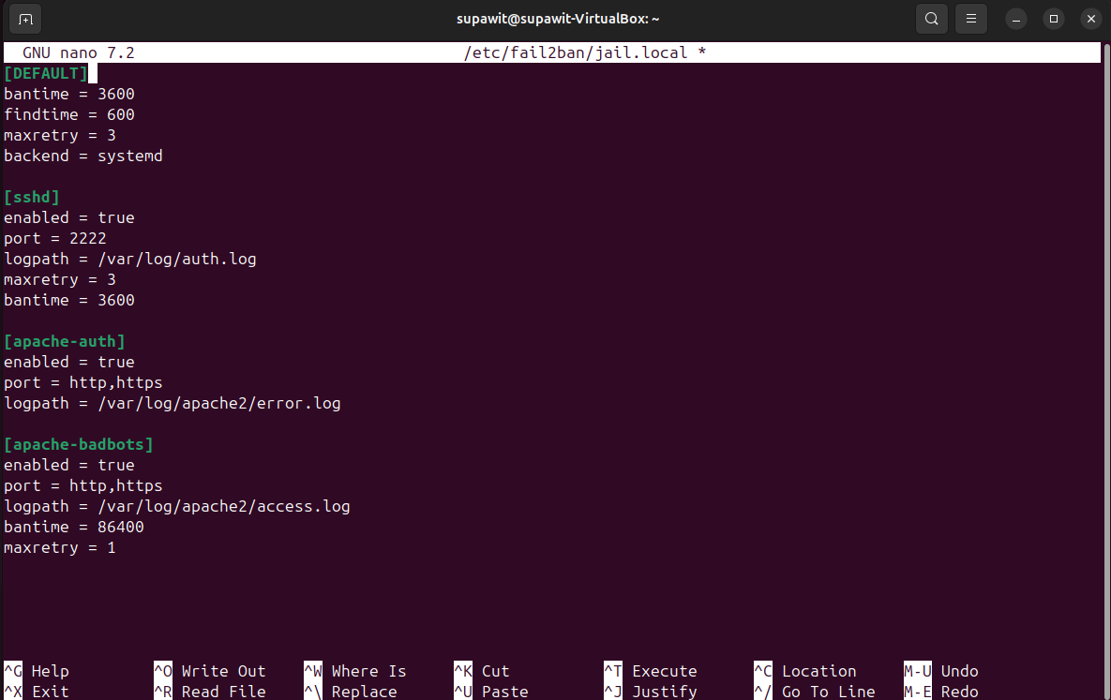

5.3 Configure System Monitoring





5.4 Configure Log Rotation



**ปัญหาที่พบและวิธีแก้ไข**  
1.มี tools บางตัวไม่ได้ติดตั้ง และพอติดตั้งแล้ว error หาไม่เจอ วิธีแก้ไขดูตามใน stack overflow และ reddit 9 ตอนนี้สามารถแก้ไขได้แล้วและใช้งานได้ปกติ